**1.ABOUT PROJECT**

Today one cannot afford to rely on the fallible and incompetent nature of human beings on carrying out crucial and complicated tasks without supervision. It has become even harder to survive in the market due to the merciless competition and it’s no longer wise to keep saying “to err is human”. It can cost dearly to rationalize your mistake and continue to keep doing it. So to keep up with time ,bring about the best outcome without malfunctions, produce greater efficiency and productivity and replace the bulky heaps of files, we propose to use a software database management system.

Software has seen an exponential rise in efficiently micromanaging medium to big organizations. Earlier, data management meant maintaining a lot of ledgers and paperwork but in the present scenario software has made things a lot easier and has offloaded a lot of stress from the employees.

In the health sector and especially in pharmacies, less stress means that the employee will work with added focus and dispatch medicines with care. It also helps to increase the employee-customer rapport which in turn helps increase the sales.

It also helps save a lot of time and money. The work becomes fully automated and any information about the establishments can be accessed on the push of a button. Moreover, this helps the organizations to have greater control over their establishments and helps prevent any malpractices.

**2.Objectives Of The Project**

Our consideration while developing this software project is to achieve the following points:

* This software is all about pharmacy management system. It provides all the facilities that are very important in a pharmacy.
* User can manage all the all the records very easily. You can generate all kinds of details like customer details, transaction details, medicine’s expiry details and so on.
* It also helps in having an easy access of records of their employees which could help in visa renewal, salary, incentive and bonuses.
* It also saves the valuable time of the person behind the software.

**3.HIERARCHICAL DIAGRAM OF THE PROJECT**

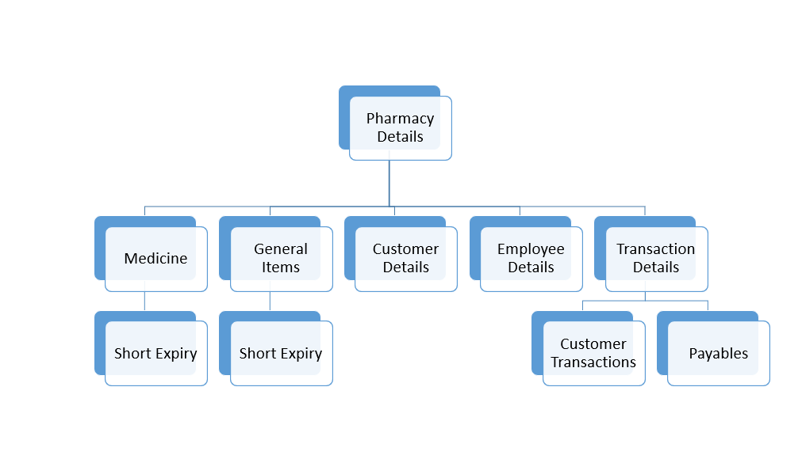

**4. DATA STRUCTURE**

**1. Entity of Pharmacy Management System:**

Pharmacy directory, employee details, Medicines, General items, short expiry, transaction history.

**2. Attributes Entities and their structure:**

**1. Pharmacy** (CR_no, Ph_Name, Ph_add, );

**2.CUSTOMER** ( Cust_id, Cust_Name, Cust_add, Cust_mno, Cust_pres);

**3. Medicines** (Med_id, Med_exp, Med_comp, Med_Name, Med_details, Med_dist, Med_qnt, Med_status);

**4. General items** (Gen_id, Gen _comp, Gen _Name, Gen _details, Gen _dist, Gen _qnt, Gen _status);

**5. EMPLOYEE** (EMP_id, EMP_Name, EMP_add, EMP_mno, EMP_Salary, Emp_job, EMP_dob, Emp_visaexp);

**6. TRANSACTION** (trans_id, trans_amt, trans_type, trans_item, trans_qnt trans_date);

**7. Short expiry** (Med_id, Med_exp, Med_comp, Med_Name, Med_details, Med_dist, Med_qnt, Med_status)

**Pharmacy Module:**

This table contains pharmacy related information

|  |  |  |  |
| --- | --- | --- | --- |
| Attribute | Data types | Size | Constraint |
| Cr_no | **Integer** | **10 byte** | Primnary key |
| Ph_Name | **String** | **30 byte** | Not Null |
| Ph_add | **String** | **70 byte** | Not Null |
| Ph_telno | Integer | 10 byte | Not Null |

**Customer Module :**

This table contains Customer related information

|  |  |  |  |
| --- | --- | --- | --- |
| Attribute | Data types | Size | Constraint |
| Cust_id | **Integer** | **10bytes** | Primnary key |
| Cust_Name | **String** | **30 bytes** | Not Null |
| Cust_Add | **String** | **70 bytes** | Not Null |
| Cust_Pno | **Integer** | **10 bytes** | Not Null |
| Cust_pres | String | 50 bytes | - |

**Employee Module:**

|  |  |  |  |
| --- | --- | --- | --- |
| Attribute | Data types | Size | Constraint |
| EMP_id | **Integer** | **10 bytes** | Primnary key |
| EMP_Name, Emp_visaexp | **String** | **30 bytes** | Not Null |
| EMP_add | **String** | **70 bytes** | Not Null  Not Null |
| EMP_mno | **Integer** | **10 bytes** | Not Null |
| EMP_Salary | **Integer** | **10 bytes** | Not Null |
| Emp_job | **String** | **10 bytes** | Not Null |
| EMP_dob | **Date** | **10 bytes** | Not Null |
| Emp_visaexp | Date | 10 bytes | Not Null |

This contains information regarding the employees.

**Medicine Module:**

|  |  |  |  |
| --- | --- | --- | --- |
| Attribute | Data types | Size | Constraint |
| Med_id | **Integer** | **10 bytes** | Primary key |
| Med_exp | **Date** | **10 bytes** | Not Null |
| Med_comp | **String** | **20 bytes** | Not Null |
| Med_Name | **String** | **20 bytes** | Not Null |
| Med_details | **String** | **30 bytes** | Not Null |
| Med_dist | **String** | **30 bytes** | Not Null |
| Med_qnt | **Integer** | **10 bytes** | Not Null |
| Med_price | String | 10 bytes | Not Null |

**General Items Module:**

This table gives information about the general items.

|  |  |  |  |
| --- | --- | --- | --- |
| Attribute | Data types | Size | This table gives information about the medicines.  Constraint |
| Gen_id | **Integer** | **10 bytes** | Primary key |
| Gen_exp | **Date** | **10 bytes** | Not Null |
| Gen_comp | **String** | **20 bytes** | Not Null |
| Gen_Name | **String** | **20 bytes** | Not Null |
| Gen_details | **String** | **30 bytes** | Not Null |
| Gen_dist | **String** | **30 bytes** | Not Null |
| Gen_qnt | **Integer** | **10 bytes** | Not Null |
| Gen_price | String | 10 bytes | Not Null |

**Transaction module:**

This gives information about the transactions within the pharmacies.

|  |  |  |  |
| --- | --- | --- | --- |
| Attribute | Data types | Size | Constraint |
| trans_id | **Integer** | **10 bytes** | Primary key |
| trans_amt | **Integer** | **10 bytes** | Not Null |
| trans_type | **String** | **20 bytes** | Not Null |
| trans_item | **String** | **30 bytes** | Not Null |
| trans_qnt | **Integer** | **10 bytes** | Not Null |
| trans_date | Date | 10 bytes | Not Null |